`
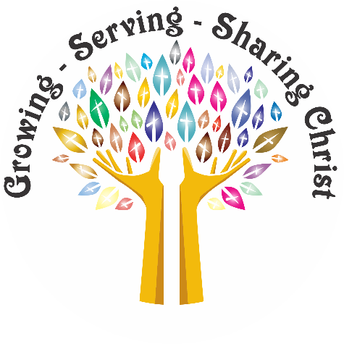
Our Mission ……….

Growing, Serving, Sharing Christ
Saint Philip Lutheran
Church and School
2500 WEST BRYN MAWR AVENUE - CHICAGO, ILLINOIS 60659
Church & School 773.561.9830 FAX 773.561.9831
Early Childhood Center 773.561.7566 FAX 773.561.3048
www.stphiliplutheran.com

The Pastor’s Page
Pastor Tom Engel

Two Kinds of People

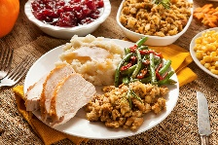
When it comes to eating Thanksgiving dinner, I have observed that there are two kinds of people. We all put on our plates a high mound of mashed potatoes with ladles of gravy, a huge turkey leg that would make Henry the VIII proud, scoops of green bean casserole, a mountian of stuffing, and whatever space is left on the plate is filled with cranberries.

One kind of person will make sure all of this food will not touch each other. This person will make sure that he takes a big spoon and makes a crater in the mound of mashed potatoes where he can pour the gravy, so the gravy does not run into the other food that is on the plate. Each food has its clear boundaries, and the cranberry sauce definitely stays in its territory.

I am the other kind of person who does not mind having the gravy spill over into the stuffing and turkey and eating some mashed potatoes with the green bean casserole. I do have to admit that I do like for the cranberry sauce to mind its own business and stay by the cranberries. When it comes to gravy, I like it pure, and even a little touch of cranberry sauce in my gravy ruins it for me.

In today’s world, we are especially are not to think of how people can fit into categories. We are to think of ourselves as belonging to one human. I do agree that we are all equal and that one person has the same rights as all other people. I do not like the idea of separating people into groups and labeling each of those groups. With race labels, we get stereotypes, and we may put limits on people. And we might start talking about good

and bad people. We know it is not our pl ace to judge others.

Even with the two kinds of people who eat their turkey dinners as mixers or dividers, I feel awkward talking about the differences than how we are alike and have unity as one people. But after saying all of this about the importamce of unity,we need to keep talking about two kinds of people because on the Last Day, there will be left two distinct groups.

Ever since Jesus’ ascension into heaven, people have been living in the End Times. All prophecies have been fulfilled, except for Jesus’ coming back on the Last Day. Jesus will on the Last Day separate the believers from the unbelievers.

Until that day, we are preparing ourselves by an “active” waiting. When I think of waiting, I think of a time
of idleness like sitting in a doctor’s office waiting to be called into the examine room, and maybe to pass the time, I flip the pages of one of their old magazines.

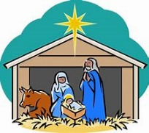
In the season of Advent, we are active by preparing ourselves for Jesus’ first coming in Bethlehem and his Second Coming on the Last Day. Looking at Jesus’ birth, we see again every year how God wanted to show the world His love. I have always liked the title of the hymn “Love Came Down at Christmas.” In the few words of the title, it hits exactly why God sent Jesus to come and dwell among us.

After the visit from the shepherds who had come to see the new-born Savior, Mary pondered in her heart and treasured this gift from God, a baby son who was born to give the love of God in a sinful world. It’s in the season of Advent that we, too, can ponder and treasure what God has done for us in Jesus.


As we approach December and Christmas, most of the world prepares for it by making a list of things to do like: present buying, cookie baking, tree decorating, and Christmas card writing. Let’s call these things the softer side of Christmas that we all enjoy. For myself, I love watching Christmas movies like Home Alone and Christmas Vacation with Chevy Chase. I identify with Clark Griswold who goes to extremes to have the perfect family Christmas, and like him, the harder that I try to make each Christmas memorable like no other, the more that things seem to fall apart.

A good lesson here is that we cannot make Christmas any better than it is because every year, it is perfect as it is. Every year, we have God’s full and perfect love in Christ. I might want to stay on the softer side of Christmas with all its festivities, but if we want to get all that we can out of the first coming of Christ and his Second Coming, we have to hear a hard message that goes with it.

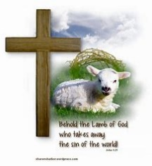
This hard message was preached by the prophets and then by John the Baptist who gave the most powerful sermons with just a few words. One sermon went like this, “Look! the Lamb of God who takes away the sin of the world.” And the other was, “Repent, for the time is
near.”

John was preaching to the crowds that included the religious leaders of the day who were one kind of people. Again, I know I am dividing people into groups, but the religious leaders thought that by their works that they were righteous. Every human is sinner, and we are all in need of repentance.

But some people for many reasons like that they do not believe in God or that they think that they are self-righteous do not see the need to turn to God.

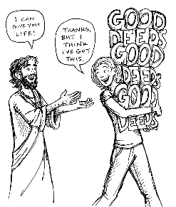
So, going back to two groups of people in the world, people are either repentant or unrepentant. For the Last Day, this distinction is most important. With all of the religions in the world, we can simplify them also into two groups. One group is one that thinks we are saved by works, and the other group believes that they are saved by grace.
Scripture tells us that Jesus is coming soon. To an eternal God, soon can be a very long time away. But for humans, we need to be on our toes and live in anticipation that Jesus can be coming at any moment. We need to be in a state of repentance, and like John the Baptist, we need to be spreading the word of the need to repent to others.

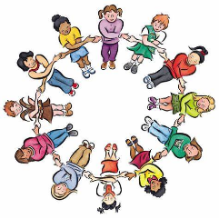
God does not want distinctions between people. He wants all people to know of the Gospel, so all people will be saved. Nothing would please God more than to see every person throughout all the world to be one people in Christ. It is my opinion that I do get from some places in Scripture that God will keep this old earth spinning and not have Jesus come again until every person has at least heard the message of the Gospel.

Knowing that God does want all people to be one in the Gospel, it seems difficult to understand why Jesus would say in his ministry that he has come to bring a sword and division in the world. But the truth is that some people will be offended by the Gospel and others will accept Jesus with open arms. As we tell others about the Jesus, and here we go again seeing the difference with people, some will love us for sharing the message of the Gospel and others will hate us for it.

With no doubt, the world is a messy place because of sin. In a way, we can say this messiness is expected and normal. Jesus said in his ministry that the world would see many horrific things like war, famine, and disease before his Second Coming. By the events that we see every day, we can say all of this chaos is true, sadly true.

But a plan is in place for all things as they are coming to an end. God told of a plan to save the world from sin right after the first humans fell into sin. God had a plan a of salvation and the prophets of old told how a
Messiah would be born, live, die, and rise to save the world. Now, we wait for Jesus to come again to take us to heaven forever.


With all of the messes in the world, and we have to admit with all the troubles in our own lives, that we need a Savior. Jesus has come and will come again. Until he comes again, our comfort is knowing that he is holding all things together as he sees best.

To make this Christmas the best Christmas ever, we can enjoy the things of the softer side of the season, but to have this Advent and Christimas to be the best ever, we need to hear and react to the message of repentance, so we have all the benfits of turning to God and to let others know of God’s grace, so the world can be one in Christ.

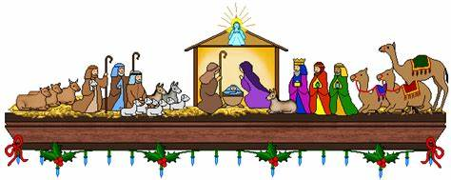

A Message from the President

Greetings Everyone,

I am sorry that I was unable to contribute an Echo article for November. My work responsibilities and volunteer hours to St. Philip just got the best of me. I was falling asleep at my computer at times I am sorry to say, so rather than having everyone wait for the publication to come out I decided to skip a month. Please forgive me.

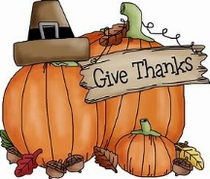
As I write this Thanksgiving is only a couple days away and I pray all of you have a very pleasant and enjoyable Thanksgiving. I hope that you have time to rest, enjoy family and friends, give thanks, and reflect on all the things God continues to provide for you. I know for me he provides everything I need. He also gives me special gifts like time to spend deer hunting and enjoying his great creation. I am happy to report that I was able to harvest a good sized buck recently during the archery season. I look forward to preparing some tasty tidbits to share with all those who attend the congregational voters meeting coming up in January. As we move through December and prepare to celebrate the birth of our Savior (God’s greatest gift of all), enjoy the time of the season, rejoice and give thanks for all that the Lord provides for you.

December brings us to the time of Advent and midweek services involving our school children. I encourage everyone to attend these services and to hear the message the children will present. Before each service will be a free will offering light dinner served by various groups, so if you are like me you can come right from work and have a little nourishment and not have to worry about picking up something or eating afterwards. Please come to enjoy the meal and the fellowship, stay for worship and the message.


December also brings us to the half way point of our fiscal year here at St. Philip. Financially we are doing much better than I had expected we would be. We knew going into the year that we would be projecting a deficit, but due to the generosity of our loving and caring congregation our deficit is smaller than projected. I pray for, and give thanks for the continued support of the congregation and all who support the ministry here at St. Philip.

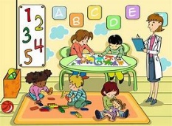
With sadness I signed the agreement to sell the Early Childhood Center building and parking lot on November 6th. I want to thank Mr. Pete Nabhani for all his work through this process, and we are now waiting for a closing date so that this process can be brought to a conclusion. The Board of Directors is reviewing several avenues to invest the proceeds of this sale to continue the ministry of St. Philip for future generations. As more information and options can be explored I am sure that God will lead us to the best course of action to take. Ultimately, what plans God has for us only God knows, but I do know we are all in this together as God has brought us together at this time to be his church St. Philip.

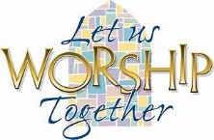
Finally, I have spoken about this on numerous occasions, but I want to continue to encourage everyone to attend worship, to attend bible study (this is held in Pastor’s living room at 9:00am prior to the worship service), always give thanks for all the Lord provides for you, pray for Pastor, the faculty and staff, our volunteers, our school children and their parents, our Board of Directors, and most importantly each other. May you be blessed in your faith journey of Growing, Serving, Sharing Christ! Have a blessed and safe Christmas season.

Yours in Christ,
Brian Tennis

Minutes of the Board of Directors Meeting
The Lutheran Church of Saint Philip
2500 West Bryn Mawr Avenue, Chicago, IL

10/28/2019 – Conference room, St. Philip Lutheran School

Present: Reverend Thomas Engel Directors: Brian Tennis, Karen Huston, Karen Andersen, Diana Maanum, Pete Nabhani, Nancy Bowman and Dianne Moriarty Advisory: Donna Tennis Excused: Mark Iverson. Guests: Andrea Bateman and congregation member Chrissy Nosko.

Reports Received: Meeting Agenda, Commission on Education and Principal’s Report, July through Sept 2019 P&L, and July through Sept 2019 P&L Budget vs. Actual comparison.

7:03 p.m. Meeting opened with prayer. President Brian Tennis welcomed guests Chrissy Nosko, who as part of a Principal Endorsement mentoring program is attending to observe how St. Philip functions, and Andrea Bateman who is St. Philip’s new part-time marketing person. Then Brian read a devotion, from Lutheran Church Charities, about receiving things from God.

Marketing Update Andrea reported on the work being done to update St. Philip’s marketing plan and out reach to the community. Andrea has also been designing flyers, has gained posting access to St. Philip’s Facebook site, and has been working to update St. Philip’s website both concept-wise and content-wise on the School side. Per the demo template the site will be more interactive, and it will be possible to do tasks like schedule school tours, ask for information and contact teachers online through the website. These website improvements will eventually be implemented on the church side also. Next steps may include personalizing school tours, making informational videos for the website, obtaining St. Philip banners through CLEF and making an entrance sign for the school building. Options for repairing the School’s electronic sign were discussed. The next big events are Trunk or Treat and the St. Nicholas celebration on December 7th.

Information Sharing The Commission on Worship is reviewing the Consecrated Stewards program materials received. In regards to the audio visual (AV) equipment and live streaming issues at the church, Pete’s contacts who work on sound systems will be asked to assess the AV situation in the sanctuary and recommend how to simplify its operation and get live streaming capabilities up and running again. The Board of Directors (BOD) agreed that separate Wi-Fi coverage for the church could be obtained if it was required for live streaming purposes. Church choir practice is starting on November 10th. In conjunction with City Grange, a grant proposal for raised gardening beds for the School was submitted. For Right to Life Sunday, January 19th, a baby shower fundraiser for a crisis pregnancy center is being planned. The possibility of sending a team, next summer, to work with a mission group at Detroit Lutheran churches is being explored. Also under consideration are holding a mission festival next fall, and seeing if we could hold a joint VBS next summer with the Syrian and Ethiopian Lutheran congregations that meet in the St. Philip sanctuary. The storage of School records and the finishing of the ECC building clean out were discussed. School playground equipment options were debated. As community outreach, during the Chicago Public Schools (CPS) strike, a CPS band program has been allowed to meet in the school building.

Property Report The proposed contract for the sale of the underused EEC building and parking lot is still being reviewed, and it was the consensus of the BOD that the contract may be signed should it meet the approval of the review team. The restructuring of parking restrictions, for the parking spaces alongside the church and school, on Campbell Ave, is being explored.

Pastor’s Notes Vonda Toner, from the Lutheran Church Extension Fund (LCEF), was invited to speak about investments during the November 18th BOD meeting. The LCEF also offers free assessments of church buildings and the work that needs to be done to maintain them. It was mentioned that Commonwealth Edison is being asked to do an energy light assessment at the School, and that one area for review would be the feasibility of HD lighting for the gym. Pastor invited the BOD to hold their December 16th meeting in his home. Members are to bring finger food to share. There are 4 students taking confirmation classes this year, and plans are to hold their Confirmation Service on Reformation Sunday 2020.

Financial Update Due to phenomenal church giving, the first quarter of this school year ended with only a $ 2,500 deficit. We have a loving and caring congregation, and the Board of Directors is so thankful for the congregation’s support of the educational mission at St. Philip. The proposed changes to the Cleaver Trust, which St. Philip was advised of, are now awaiting the State Attorney General’s approval. Advice regarding the petitioned changes (cost approximately $ 3.8 K) was provided, pro bono, by the Lutheran Lawyer’s League.

9:03 p.m. Meeting ended with prayer.

Minutes submitted respectfully,
Dianne Moriarty, Clerk



PRINCIPAL’S REPORT – DECEMBER 2019
St. Philip Lutheran School + Chicago, Illinois

Would You Rather…?

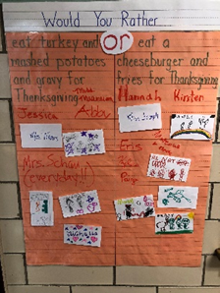
Have you asked that type of question? During the month of November our Kindergarten, First, and Second graders were greeted each day with a “Would You Rather” question. Questions centered on the topic of Thanksgiving. We invited the school to join the fun and answer the questions as well. Parents even joined in the fun. There was a great sense of community as the school participated.

Some of the questions were easy to answer such as “Would you rather eat turkey and mashed potatoes and gravy for Thanksgiving? Or Would you rather eat a cheeseburger and fries for Thanksgiving?” Other questions took some pondering, such as “Would you rather wash your hair with mashed potatoes? Or Would you rather wash your hair with gravy?” It certainly was interesting to hear the rationale behind some of the answers! So, how would you respond?

Banners on Bryn Mawr

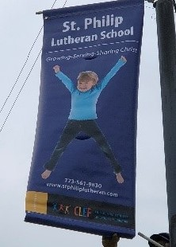
Did you notice our new street pole banners in front of school when you drive down Bryn Mawr? Thank you to the Chicagoland Lutheran Educational Foundation (CLEF) for the purchase of these banners. We are grateful for the new signs and advertising. Look for additional signs coming soon.

Advent Season Begins
With the Thanksgiving holiday late this year, it seems like there is more of a rush to prepare for Christmas. The stores certainly want everyone to get ready earlier, with all the Christmas decorations put up before Halloween. No matter if we are ready or not, the Christmas season is upon us. December 1 marks the first Sunday in Advent. With that comes a preparatory time of waiting and watching. We wait for the “coming” of Christ into flesh and the celebration of Christmas.
Classes began Advent service preparations before Thanksgiving. Children learned new songs and recitations for their Advent services. The students will lead the first two mid-week Advent services on December 4, 11 at 6:30 p.m. Student and adult musicians will lead the third service, on December 18. Make plans to join us for these services and the meal prior to the service beginning at 5:15 p.m. If you cannot attend the evening service, you are welcome to attend the chapel service at 9:00 a.m. each week. The chapel service is a “dress rehearsal” for the evening service.
December 4 “Hark the Herald Angels Sing” Preschool-2nd grades lead
December 11 “Jesus Comes Home” 3rd-8th grades lead
December 18 Service of music and song Student and adult musicians lead

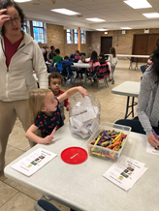
St. Philip is joining the global movement on December 3, 2019. Our school set out a challenge for our students. We wanted to help someone outside our St. Philip community. Each classroom selected a charity. The four charities were Make a Wish (Preschool), Project Linus (Kindergarten, First, Second grades), Loggerhead Marine Life Center (Fourth, Fifth grades), and Phil’s Friends (Sixth, Seventh, and Eighth grades). Classes made posters to inform others about their charity. The school then voted on one charity. Parents and Facebook friends voted as well. Make a Wish received the most votes. The Make a Wish foundation helps to make life better for children battling critical illnesses. Our goal is to raise at least $250.00 for Make a Wish. Won’t you consider making a donation to grant the wish of a child? You may drop off your donation at St. Philip. If paying by check, please make checks payable to St. Philip. St. Philip will then write one check for the donations. Contact Mrs. Tennis (dtennis@stphiliplutheran.com or 773.561.9830) with any questions.

St. Nicholas Celebration:
Join us on Saturday, December 7 from 10 AM-11:30 AM in the church basement. The fun includes ornament and cookie decorating, fellowship, and a visit from someone special. Bring a friend!

In closing, as you gather together with family and friends this Christmas season may you reflect on the meaning of Christ coming into the flesh in order to save us from our sins. May the joy of the Christmas season remain in your heart always!

On behalf of the St. Philip staff, I wish you a blessed Christmas and a joyous New Year!

In Christ,
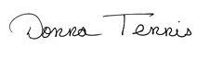
Principal

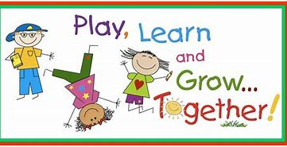

Outreach Cookie Bake

Thank you to all who helped bake and decorate boxes for our Outreach Cookie Bake on November 17. Some people baked, some decorated boxes, while others packed the boxes with delicious treats. We included a postcard inviting the recipient to our December events at the church and school. We asked families at the Thanksgiving potluck to take a box and share with a neighbor or area business.

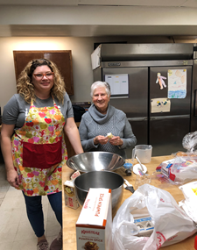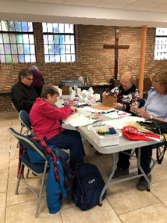
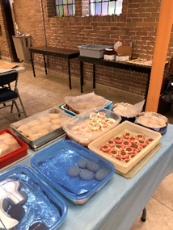

St. Philip Marketing and Enrollment

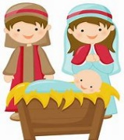
The joyful voices of St. Philip students are ringing through our school and church. Advent worship lines are diligently being practiced in class and at home. Fall colors have been quickly replaced by the traditional red and green of the season. All of these things must mean that the busy Christmas season is upon us. A season filled with Advent services, celebrations of the birth of Jesus, and quality time spent with family and friends.

This time of year is also significant in the enrollment season. As we begin a new calendar year, parents begin to search out the perfect school fit for their children.
As Marketing & Enrollment Director here at St. Philip, I have the pleasure of helping families make the important connection that comes with finding that perfect fit.
Families are drawn to St. Philip for several key reasons. Our small class sizes foster meaningful interaction between children and teachers. At St. Philip, parents will find a place where their children will be loved and challenged rather than getting lost in the crowd. The atmosphere at St. Philip is Christ-centered and life-giving. Many parents desire consistency between home, church, and school. They appreciate the way that teachers both encourage and support their students. Children participate in classroom life and are challenged to grow both intellectually and spiritually. Students are engaged every day in a broad number of subject areas. They are encouraged to love their studies and to find delight in God’s creation. Through lessons in Growing - Serving - Sharing Christ, St. Philip students are equipped with the tools they need for a lifetime of learning and service.


If these ideas resonate with you, we invite you to come and visit St. Philip. We would also appreciate you “referring” St. Philip to those you may know, who are are looking for a school-home. While we hope that the information on our website is helpful, seeing the “life” of the school is essential. Our many options for campus visits are tailored to each family and many adult observers even comment that they would like to enroll as students themselves!

• Our School Tours allow parents to observe our classrooms in action and have questions answered by Principal Tennis.
• At our winter Open House, students, parents, board members, and teachers are on hand to allow your questions to be fully answered.
• Our Preschool Preview allows your student to interact in our classroom environment. Your child will experience our method of learning as they play with different materials provided during the course of the day.

Please feel free to contact me at 773-561- 9830 or via email at abateman@sphiliplutheran.com. I look forward to meeting you and talking about the rich learning environment at St. Philip!

Wishing you all a very Merry Christmas!
Andrea Bateman

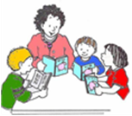
Senior Book Buddies
Barb Uber

The Senior Book Book Buddies will not meet in December. Our next meeting will be Wednesday, January 15 at 9:00 am. Every one is welcome!


Lydia Guild
By Barb Uber

The Lydia Guild will have a night out on December 10.
we will have a holiday dinner at Diversey River Bowl.

Call Barb Uber to make your reservation 847-647-2245.

Advent and the Advent Wreath
By Gloria Messerschmidt

The Season of Advent (coming) comprises the four weeks preceding Christmas. This year the First Sunday in Advent is Sunday, December 1st. The word “advent” is from the Latin word for “coming” and describes the coming of our Lord Jesus Christ into the flesh. A special custom (which dates back to the time of Martin Luther) is the Lighting of the Advent Wreath. It is a circular evergreen wreath with four candles and the Christ Candle is in the center.


The circle of the wreath reminds us of God, His Eternity and Endless Mercy. The green of the wreath reminds us of the Hope we have in God. The candles symbolize the Light which we receive from God and the Birth of His Son. The color of the candles is purple or blue with the 3rd candle being pink.
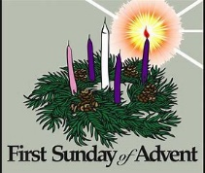
The 1st Candle is The Prophecy Candle or The Candle of hope -- It reminds us that God is faithful to us and will keep the promises He has made to us. Our hope comes from God. “May the God of Hope fill you with all joy and peace as you trust in Him; so that you may overflow with hope by the power of the Holy Spirit.” (Romans 15:13)

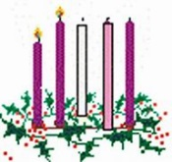
The 2nd Candle is The Bethlehem Candle or The Candle of Preparation -- God kept His Promise of a Savior who would be born in Bethlehem. Preparation means “Get ready to welcome You, O God!” “Prepare the way for the Lord, make straight paths for him. Every valley shall be filled in, every mountain and hill made low. And all mankind shall see God’s Salvation.” (Luke 3:4-6)

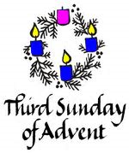
The 3rd Candle (pink) is The Shepherd Candle or The Candle of Joy -- The Angels sang a message of Joy. “An Angel of the Lord appeared to them, the shepherds, and the glory of the Lord shone around them . . . The shepherds said to each other, Let’s go to Bethlehem and see what the Lord has told us.” (Luke 2:9-15)

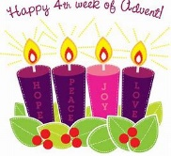
The 4th Candle is The Angel Candle or The Candle of Love -- The Angels announced the good news of a Savior. “I bring you good news that will cause great joy for all the people. Today, your Savior, Christ the Lord, was born.” (Luke 2:10-11) God sent His only Son to earth to save us because He loves us.

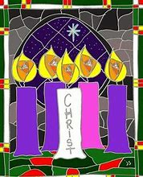
The 5th Candle (white) in the center, is The Christ Candle -- It is lit on Christmas Eve and on Christmas Day. It reminds us that Christ’s birth is the heart of the Season. “Look, this is the Lamb of God, who takes away the sin of the world.” (John 1:29) Jesus is the spotless Lamb of God giving light to the world.

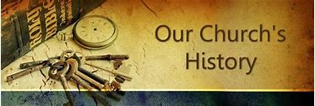

December - A Step Into Saint Philip History
By Gloria Messerschmidt

December 2, 1957 -- 62 Years Ago, the first issue of “The Echo” was published. It was first a weekly Parish Newsletter, published on Monday of every week. After a variety of formats, it became, as we know it now, a monthly publication.


DECEMBER 3, 1972 -- The burning of Saint Philip’s Mortgage took place during the 11:00 A.M. Worship Service. It was the first time in the then 79 year history of Saint Philip that the Church had no commercial Mortgage indebtedness.

DECEMBER 4, 1966 -- The Memorial Sanctuary Lamp was dedicated in Memory of The Rev. Otto L. and Mrs. Christine E. Messerschmidt. The Lamp is a constant reminder of the continual presence of God in the Chancel and in His House and in our lives.

DECEMBER 11, 2011 -- The Sanctuary Candles were dedicated in Memory of Miss Edna Messerschmidt (Miss Edna).
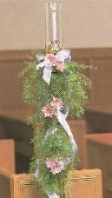
DECEMBER 24, 2014 -- The Pew Candles were dedicated during the Family Christmas Eve Service. They consist of 13 Candle Holders and are hand carved of hardwood with brass candle sockets and glass chimneys.

DECEMBER 25, 1983 -- Christmas Day -- The Harpsichord was dedicated in Memory of Mr. Arthur C. Streetz.
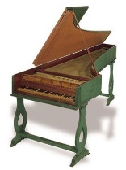



December Birthdays

1 – Matthew Carlson 18 – Maria Huprich
2 – Linda Bogseth Barbara Uber
5 – Melissa Meinecke 20 – Heidi Gartner
7 – Julie Berglund 21 – Frieda Radke
8 – Sabina Glaser Jason Strohmayer
9 – Barbara Nosko 22 – Johann Huprich 10 – Ty O’Connor 23 – Joseph A. Eipl 11 – Glenn Sugiyama Claudia Franz
14 – Mathias Gartner Tanner O’Connor
15 – Megan Larsen 24 – Michael Strohmayer
16 – Holly Cesena 26 – Anthony Cesena
Lillianna Keller 27 – Debra Doyle 17 – Ryan Meinecke Gail Forsan



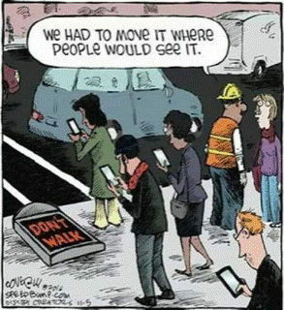

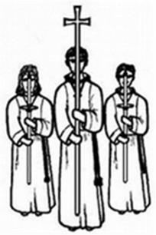

December Service Assistants

Nursery:

December 1 – Dee Dee O’Connor
December 8 – Karen Anderson
December 15 – Karen Huston
December 22 – Dee Dee O’Connor
December 24
5:00 PM – No Nursery
11:00 PM – No Nursery
December 25 – No Nursery
December 29 – Karen Anderson

Lector:

December 1 – Thom Paker
December 8 – Nancy Bowman
December 15 – Karen Huston
December 22 – Donna Tennis
December 24
5:00 PM – Karen Huston
11:00 PM – Donna Tennis
December 25 – Lynn Walsh
December 29 – Thom Paker

Acolyte:

December 1 – Tre O’Connor
December 4 – Hannah S
December 8 – Andrew V
December 11 – Ty O’Connor
December 15 – Aiden N
December 18 – Theo Huston
December 22 – Emily Schau
December 24
5:00 PM – Tre O’Connor
11:00 PM – Hannah S
December 25 – None
December 29 – Andrew V

Communion Assistants:

December 1 – David O’Connor & Tanner O’Connor
December 8 – David O’Connor & Thom Paker
December 15 – David O’Connor & Matt Schau
December 22 – Brian Tennis & Chris Amundson
December 24
5:00 PM – No Communion
11:00 PM – Brian Tennis & Thom Paker
December 25 – No Communion
December 29 – 5th Sunday, No Communion

Deacons & Ushers:

December 1 – Joe Eipl (Deacon)
Thom Paker
December 4 – Joe Eipl (Deacon)
December 8 – Joe Eipl (Deacon)
Thom Paker
December 11 – Joe Eipl (Deacon)
December 15 – Joe Eipl (Deacon)
Theo Huston
December 18 – Joe Eipl (Deacon)
December 22 – Joe Eipl (Deacon)
December 24
5:00 PM – Joe Eipl (Deacon)
Theo Huston
11:00 PM – Joe Eipl (Deacon)
Thom Paker
December 25 – Joe Eipl (Deacon)
December 29 – Joe Eipl (Deacon)

